Elvia Nine Card

Feature Portfolio

Version <1.0>

Submit Date<23 JUNE 2013>

Revision History
Date | Version | Description | Author
<23 JUNE 2013> | <1.0> | Feature Portfolio | Cris Kamurai

Table of Contents

1. Introduction 4

1.1 Purpose 4

1.2 Scope 4

1.4 References 4

2. Title Selection 5

3. Title Menu Selection 6

4. Help / Information Screens 8

5. In-Game Menu Actions 9

6. In-Game Menu Navigation 11

7. In-Game Menu Options 13

8. Supporting Information 14
Appendix 14

Feature Portfolio

1. Introduction
<State what this document is and related documents.>

This document is designed to express which features will be required for the project to work effectively.

Purpose
<State the purpose of this document and what information it is supposed to provide.>

The purpose of this document is to determine which features will be necessary for the program, based on the needs of the project.

Scope
<This section should list the goals, and priorities of what is to be accomplished in this document.>

The scope of this document is to use basic language, supported by UML diagrams, to explain and determine the project’s feature, most likely per screen.

References
<This section should list references to information sources outside the creative properties of the authors>

All GDR documentation for the Elvia Nine Card card game and the Antarrea universe.

2. Title Selection
<This section should contain a full listing, possibly divided into sub categories, of features that are to available to be used for each Title screen designed in the game.>

2.1 Feature List
Navigate to Title Menu Screen gotoMenu:
Load starting menu screen.

View Title displayTitle:
Display title for player to view.
2.2 Title Use Case Diagram
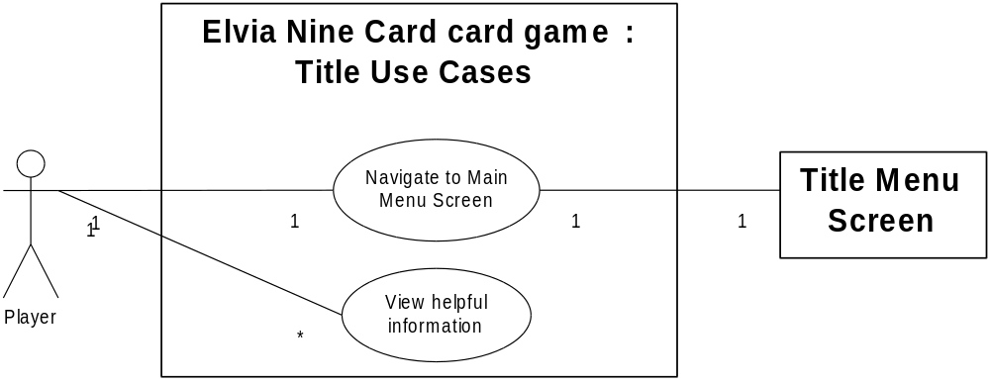

3. Title Menu Selection
<This section should contain a full listing, possibly divided into sub categories, of features that are to available to be used for each Title Menu screen designed in the game.>

3.1.1 Title Menu
Navigate to Deck Building Screen gotoDeckBuilding:
Load Deck Building screen.

Navigate to Playable Screen gotoDeckPlay:
Load Playable screen.

Navigate to Credits Screen gotoCredits:
Load Credits screen.

Navigate to Information Screen gotoInformation:
Load Information screen.

3.1.2 Title Menu Use Case Diagram
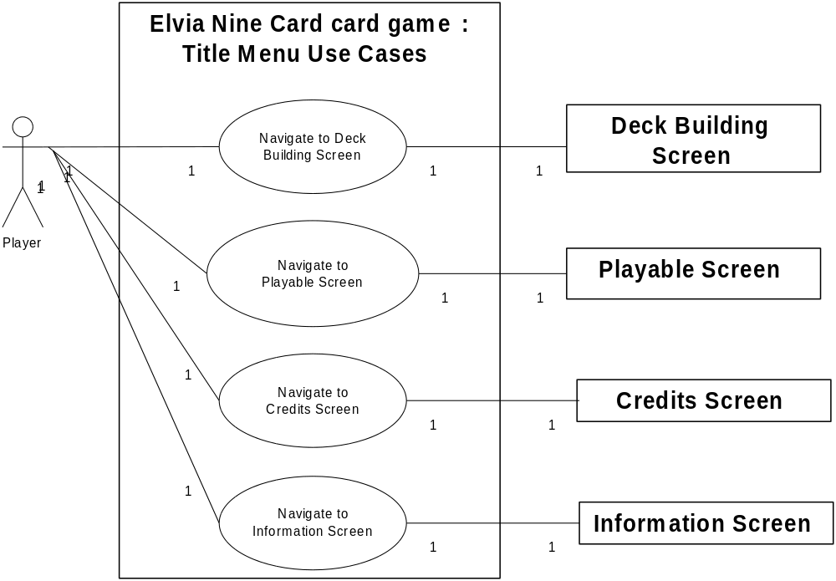

3.2.1 Deck Building
Navigate to a previous screen gotoPrevious:
Load the previous screen (objects should be loaded from server)

Create a new deck createDeck:
Create a new (empty) deck

Select a previously built deck selectPreDeck:
Load the current deck from the selected previously built deck.

Add a card to the current deck. addToDeck:
Add selected card to currently selected deck.

Remove a card from the current deck removeCard:
Delete the card from the currently selected deck and consolidate the cards.

Delete the current deck deleteDeck:
Delete the currently selected deck, update the written record.

View cards in current deck loadDeck:
Display cards in currently selected deck.

3.2.2 Deck Building Use Case Diagram

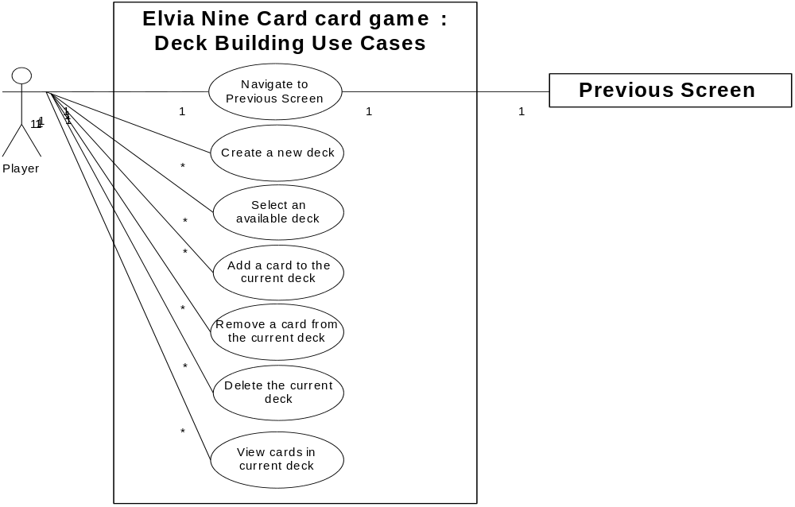

4. Help / Information Selection
<This section should contain a full listing, possibly divided into sub categories, of features that are to available to be used for each Help / Information Screen.>

4.1.1 Title Information
Navigate to Title Menu gotoTitleMenu:
Load the Title Menu screen.

Navigate to Information gotoInformation:
Load the Information screen.

4.1.2 Title Information Use Case Diagram
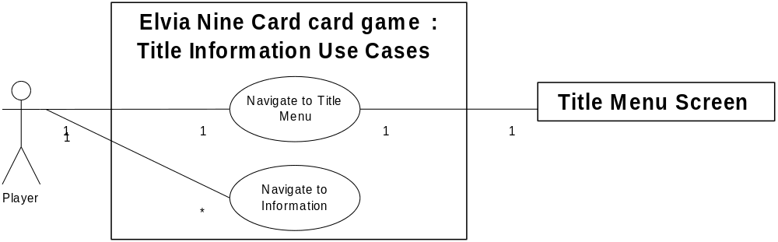
4.2.1 F1 Screen
Navigate to a previous screen gotoPrevious:
Load the previous screen (objects should be loaded from server)

View helpful information displayInfo:
Display helpful information.

4.2.2 F1 Information Use Case Diagram
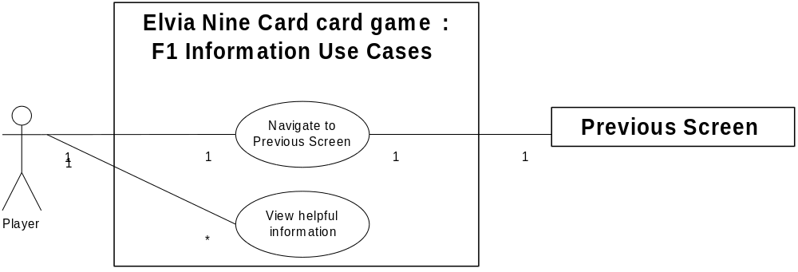

5. In-Game Actions
<This section should contain a full listing, possibly divided into sub categories, of features that are to available to be used for each Maine Menu screen designed in the game. This includes Command Bars and HUDs (Heads Up Displays)>

5.1 In-Game Features
Navigate to Deck Building Screen gotoDeckBuilding:
Load Deck Building screen.

Navigate to Title Menu Screen gotoMenu:
Load starting menu screen.

Activate command card activateCommandCard:
Load starting menu screen.

Launch an assault launchAssault:
Load starting menu screen.

Play a creature from hand playCreature:
Load starting menu screen.

Discard card from hand discardCard:
Load starting menu screen.

View current player's control displayCurrentPlayer:
Load starting menu screen.

Switch to the next player's control switchPlayers:
Load starting menu screen.

5.2 In-Game Use Case Diagram

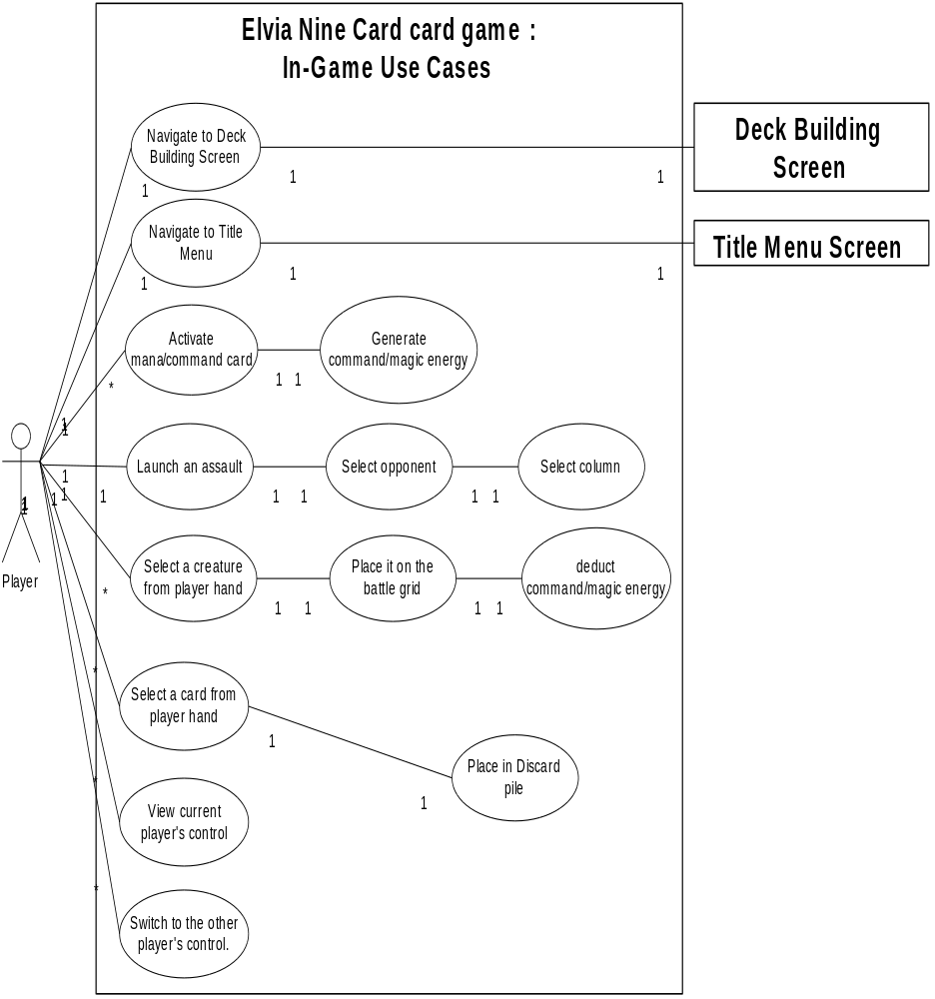

6. In-Game Navigation
<This section should contain a full listing, possibly divided into sub categories, of features that allow the user to navigate the in-game environment.>

6.1 In-Game Navigation
Select a card selectCard:
Select a card available on the screen.

Select a deck select Deck:
Select a deck available on the screen.

Draw a card from a deck drawFromDeck:
Draw a card from a deck available on the screen.

Place a card placeCard:
A selected card is place on the available screen.

Activate a card activateCard:
Activate a card available on the screen.

Move a creature moveCreature:
Move a selected creature on the Battle Grid to a new space.

6.2 In-Game Navigation Use Case Diagram

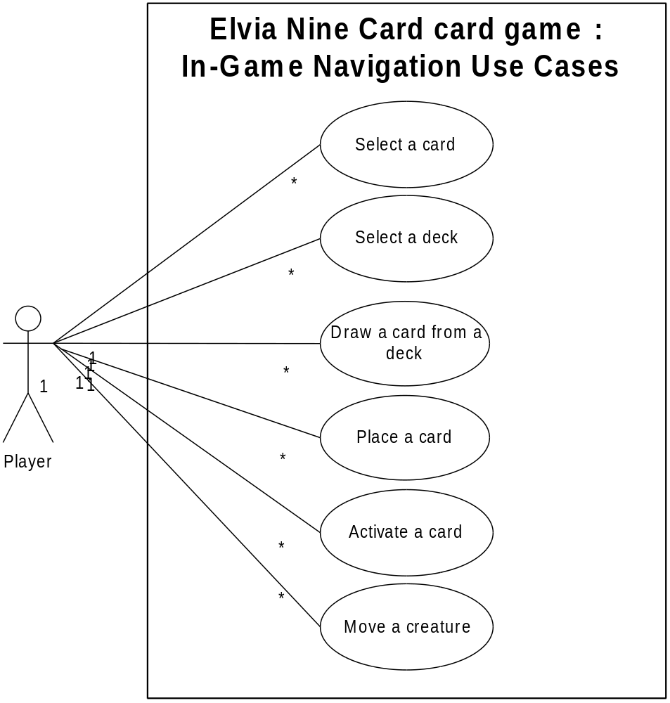

7. In-Game Options
<This section should contain a full listing, possibly divided into sub categories, of features that allow the user to take actions in the in-game environment.>

7.1 In-Game Options
F1: Information Screen optionF1:
Display the information screen.

F2: Restart optionF2:
Restarts the game back to the title screen.

7.2 In-Game Menu and Option Use Case Diagram

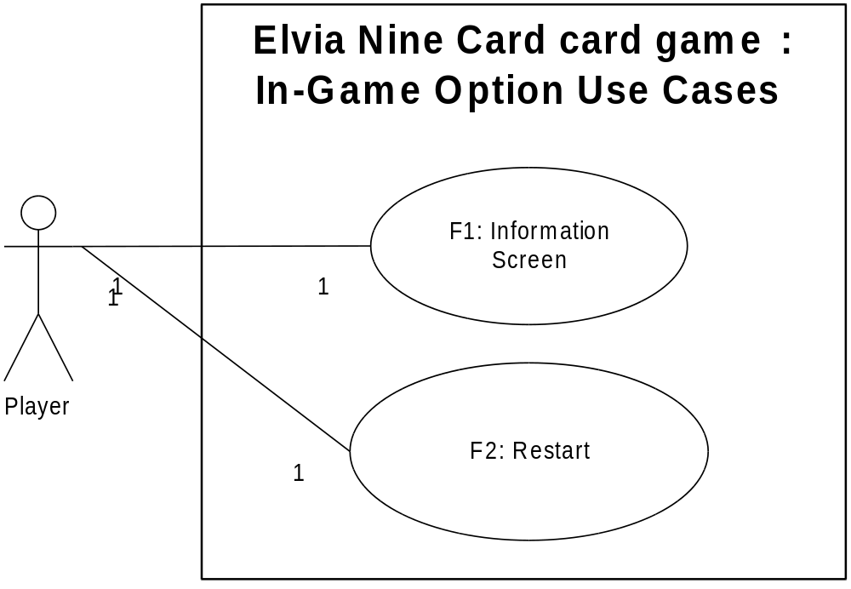

8. Supporting Information
<Any further information or locations at which further information may be obtained may be listed here.>

The inter-screen navigation is as follows, based on the previous sections’ requirements.
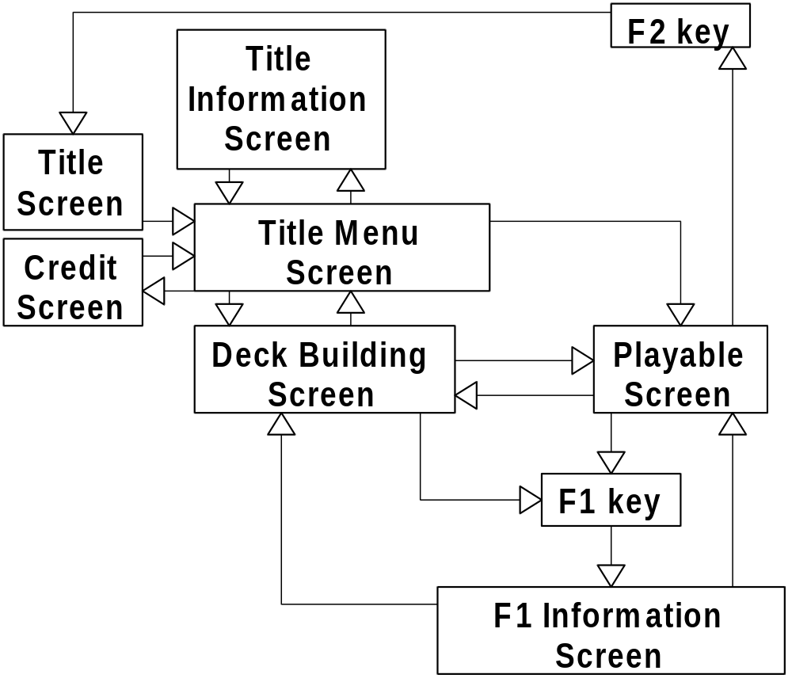

Appendix:
<Additional documentation that does not warrant an entirely separate document may be listed here.>

Index
Page

1. Introduction 4

1.1 Purpose 4

1.2 Scope 4

1.4 References 4

2. Title Selection 5

3. Title Menu Selection 6

4. Help / Information Screens 8

5. In-Game Menu Actions 9

6. In-Game Menu Navigation 11

7. In-Game Menu Options 13

8. Supporting Information 14
Appendix 14

